# **Project 8 Technical Design**

# Components

* Oracle 12c database installed on cloud for storing data
* Java based REST APIs to write/read from the database

# Design Approach

Before using the system, mini golf location has to be on-boarded to the system via a REST API call.

Customer first name and last name are passed to a java REST API centrally hosted to update the database. This API will return a unique customer ID which will be stored on the swipe card.

Round/score information for a customer will be read from the card and passed to a java REST API centrally hosted to update the database.

Information retrieval for printing scores on the score card will be in real time.

# Database Design

We will store the data in four tables Customer, Score, Par, MiniGolfPlace.

MiniGolfPlace table will contain below attributes –

1. MiniGolfPlaceID – Number(38) auto generated numeric sequence
2. Name – Varchar(250) name of the mini golf place
3. City – Varchar (250) to store the city where the mini golf place is located
4. State – Varchar(250) to store the name of the state where the mini golf place is located
5. Country - Varchar(250) to store the name of the country where the mini golf place is located
6. Creation time – Datetime field to store when the record is created for the mini golf place

Par table will contain below attributes –

1. MiniGolfPlaceID – Number(38) stores the unique ID of the mini golf place
2. HoleNumber – Number (2) (should be a positive Integer with max value 18)
3. Par – Number (2) – Par for the hole

Customer table will contain below attributes –

1. MiniGolfPlaceID – Number(38) stores the unique ID of the mini golf place
2. CustomerID – Number(38) auto generated numeric sequence
3. First Name – Varchar (50) to store the first name of the customer
4. Last Name – Varchar (50) to store the last name of the customer
5. Creation time – Datetime field to store when the card as requested

Score table will contain the below attributes –

1. MiniGolfPlaceID – Number(38) stores the unique ID of the mini golf place
2. CustomerID – Number(38) This will store the customer unique id
3. HoleNumber – Number (2) (should be a positive Integer with max value 18) – This will store the number of the hole from the swipe station
4. NumberOfStrokes – Number(4) (should be a positive integer)

Java Classes

Java classes will be created for each of the above tables and will be invoked from java REST APIs.

Java REST APIs Design

APIs will accept name input parameters and return output as json

### createMiniGolfPlace

Inputs: Name of the mini golf place(String), City where the mini golf place is located (String), State where the mini golf place is located (String), County where the mini golf place is located (String)

Ouputs: MiniGolfPlaceID (BigInteger)

### populatePar

Inputs: MiniGolfPlaceID (BigInteger), HoleNumber(Integer), Par (Integer)

Ouputs: None

### createCustomer

Inputs: MiniGolfPlaceID (BigInteger), Customer First Name (String), Customer Last Name (String)

Ouputs: Customer ID (BigInteger)

### postScore

Inputs: MiniGolfPlaceID (BigInteger), CustomerID(BigInteger), HoleNumber(Integer), NumberOfStrokes (Integer)

Ouputs: None

### getScore

Inputs: MiniGolfPlaceID (BigInteger), CustomerID(BigInteger)

Ouputs: Customer First Name (String), Customer Last Name (String), Hole Number (Integer), Current Score (Integer), Par (Integer)

### getScoreByQRCode

Java API read QR code will derive MiniGolfPlaceID and CustomerID and call getScore API.

Inputs: QR Code

Ouputs: Customer First Name (String), Customer Last Name (String), Hole Number (Integer), Current Score (Integer), Par (Integer)

Data Flow

* Onboarding a new mini golf place location

This needs to be done only once for every location.

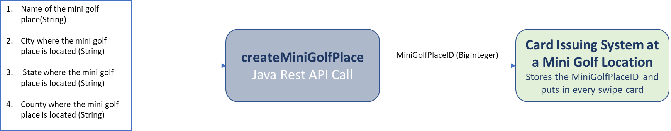

* Maintaining par for holes in mini golf place location

This needs to be done only once for every location or as when a update is needed.

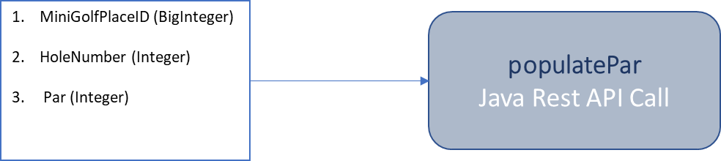

* Onboarding a Customer

This needs to be done for every time a customer shows up to play a round.

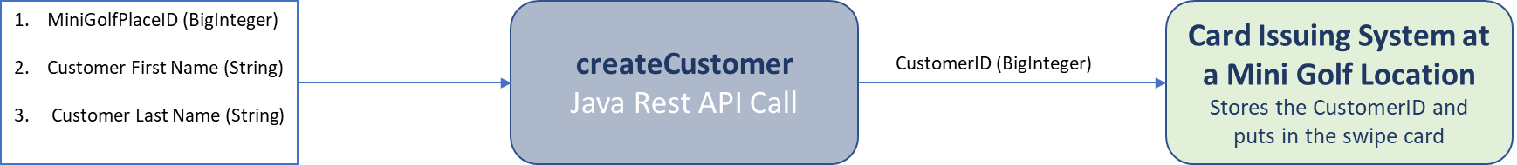

* Swiping the card at reader at every hole

This needs to be done every time a customer finishes a hole

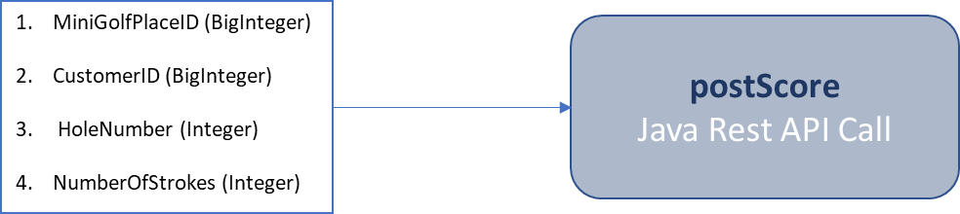

* Read score at every hole and at the end of round for printing

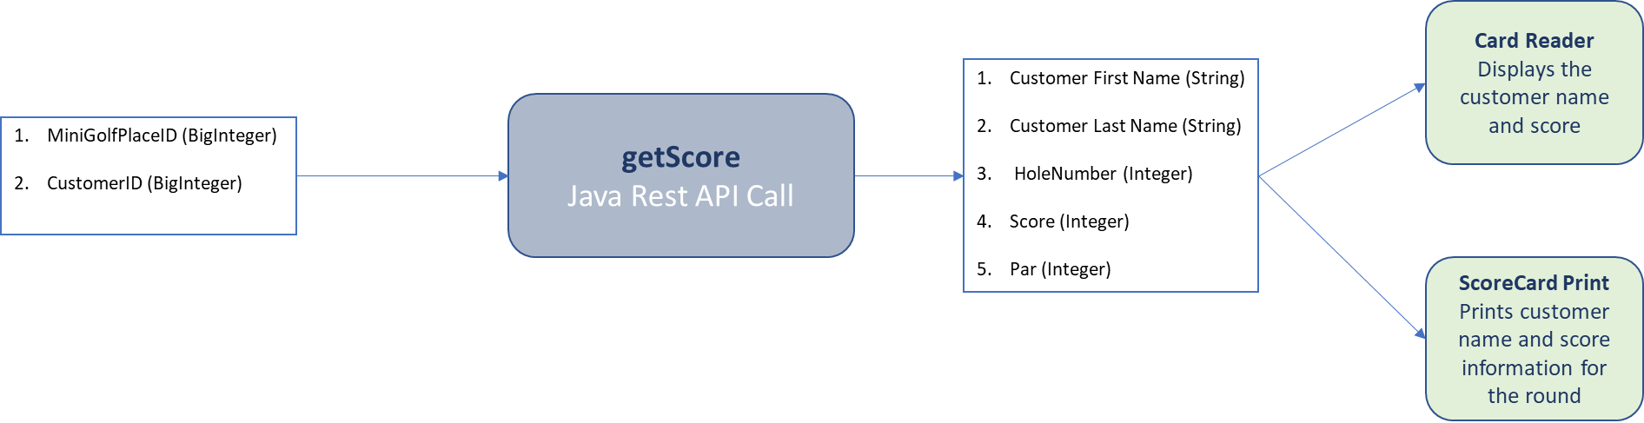

Unit test Cases

### Customer Class

* Customer First Name and Last Name are correctly stored
* Customers with the same first name and last name at a location are assigned different customer IDs.

### MiniGolfPlace Class

* Country is validated against a valid list of countries
* State is validated against a valid list of states for the country
* City is validated against a valid list of cities against a country/state

### Par Class

* HoleNumber less than 1 and greater than 18 is not allowed

### Score Class

* HoleNumber less than 1 and greater than 18 is not allowed
* Score less than 1 is not allowed
* Score cannot be updated